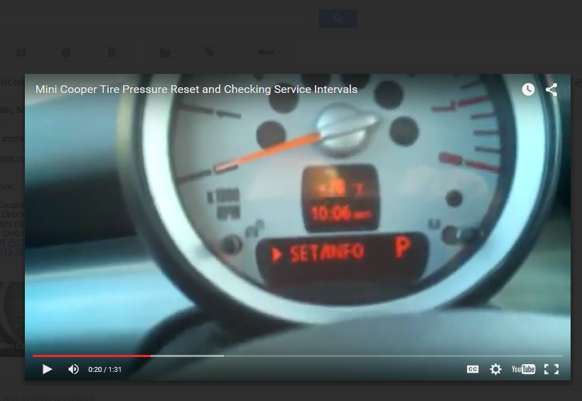
This is where it stops when I try to do this. I get the windshield washer setting, I got the Info to come up once; but then it went back to mpg etc…. I can’t get it to the Info part of the screen. I have been able to do this in the past (ie when I got new tires) but otherwise don’t fiddle with it much.

