64 31 010
Replacing microfilter for interior ventilation

RISK OF DAMAGE
Damage to the heating and air conditioning system.
Use of unapproved microfilters may cause impairment of functions in the air conditioning.
Only operate the heating and air conditioning system with the specified microfilter.
PRELIMINARY WORK
1 – Remove instrument panel trim, bottom right
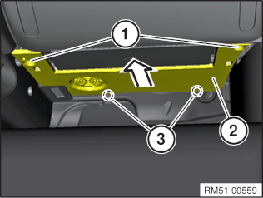
Loosen screws (1).
Slightly lower the trim panel (2)and disconnect the plug connection behind it.
Pull out the trim panel (2) from the guides (3) and feed out.
2 – Removing side centre console trim panel
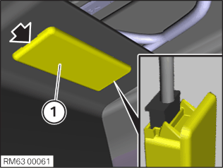
Lever out the footwell light (1) at the marked position with the special tool 0 493 681 (64 1 020).
Disconnect the associated plug connection and remove the footwell light (1).
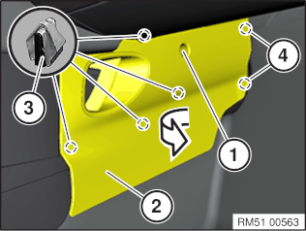
Loosen screw (1).
Loosen centre console trim panel (2) on the side from the retaining clips (3).
Guide centre console trim panel (2) from the side out of the guides (4) and remove.
MAIN WORK
3 – Remove microfilter for passenger compartment ventilation
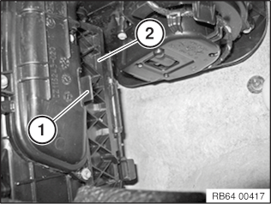
Unlock lock (1).
Open flap (2).
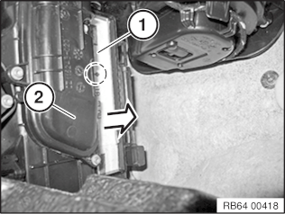
Pull out the upper microfilter (1) from the heating and air-conditioning unit (2) in direction of arrow.
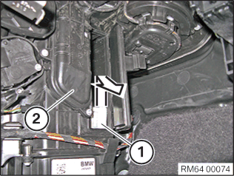
Pull out the lower microfilter (1) from the heating and air-conditioning unit (2) in direction of arrow.
4 – Installing the microfilter for the interior ventilation
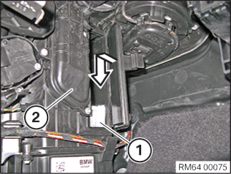
Install the lower microfilter (1) in the heating and air-conditioning unit (2) in direction of arrow.
Note: Pay attention to the direction of installation of the lower microfilter (1).
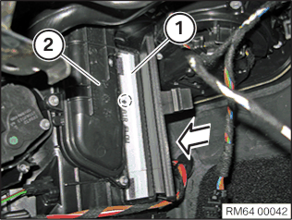
Install the upper microfilter (1) in the heating and air-conditioning unit (2) in direction of arrow.
Note: Pay attention to the direction of installation of the upper microfilter (1) in the marked area.
Close flap (2).
Lock the lock (1).
POSTPROCESSES
5 – Install the trim panel of the centre console at the side

TECHNICAL INFORMATION
Latch mechanisms, guides and mounting elements must not be damaged or missing.
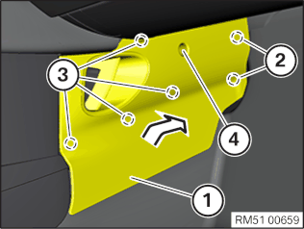
Feed in the trim panel (1) of the centre console trim into the guides (2) and clip it in with the clips (3) .
Tighten down screw (4).
Trim panel to holder, bottom
Screw
Tightening torque
2,4Nm
Connect the associated connector and engage the footwell light (1) onto the latch mechanism (arrow).
6 – Installing the bottom right instrument panel trim
TECHNICAL INFORMATION
Latch mechanisms, guides and mounting elements must not be damaged or missing.
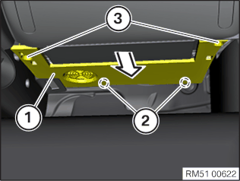
Feed in the trim panel (1) in the guides (2).
Connect the plug connection behind it.
Set the trim panel (1) upwards and tighten the screws (3).
Trim panel to holder, bottom
Screw
Tightening torque
2,4Nm

Additional Information

Overview of Tightening Torques
Used in step56
Trim panel to holder, bottom
Screw
Tightening torque
2,4Nm

Overview of Special Tools
0 493 681 (64 1 020)
Hook
Used in step2
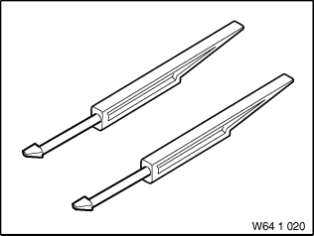
Common
Usage | (release hook) For releasing and removing fresh air grille. For removing various covers.
Included in the tool or work
Storage location | C2
Replaced by
In connection with
SI-Number | 01 15 99 (483)

